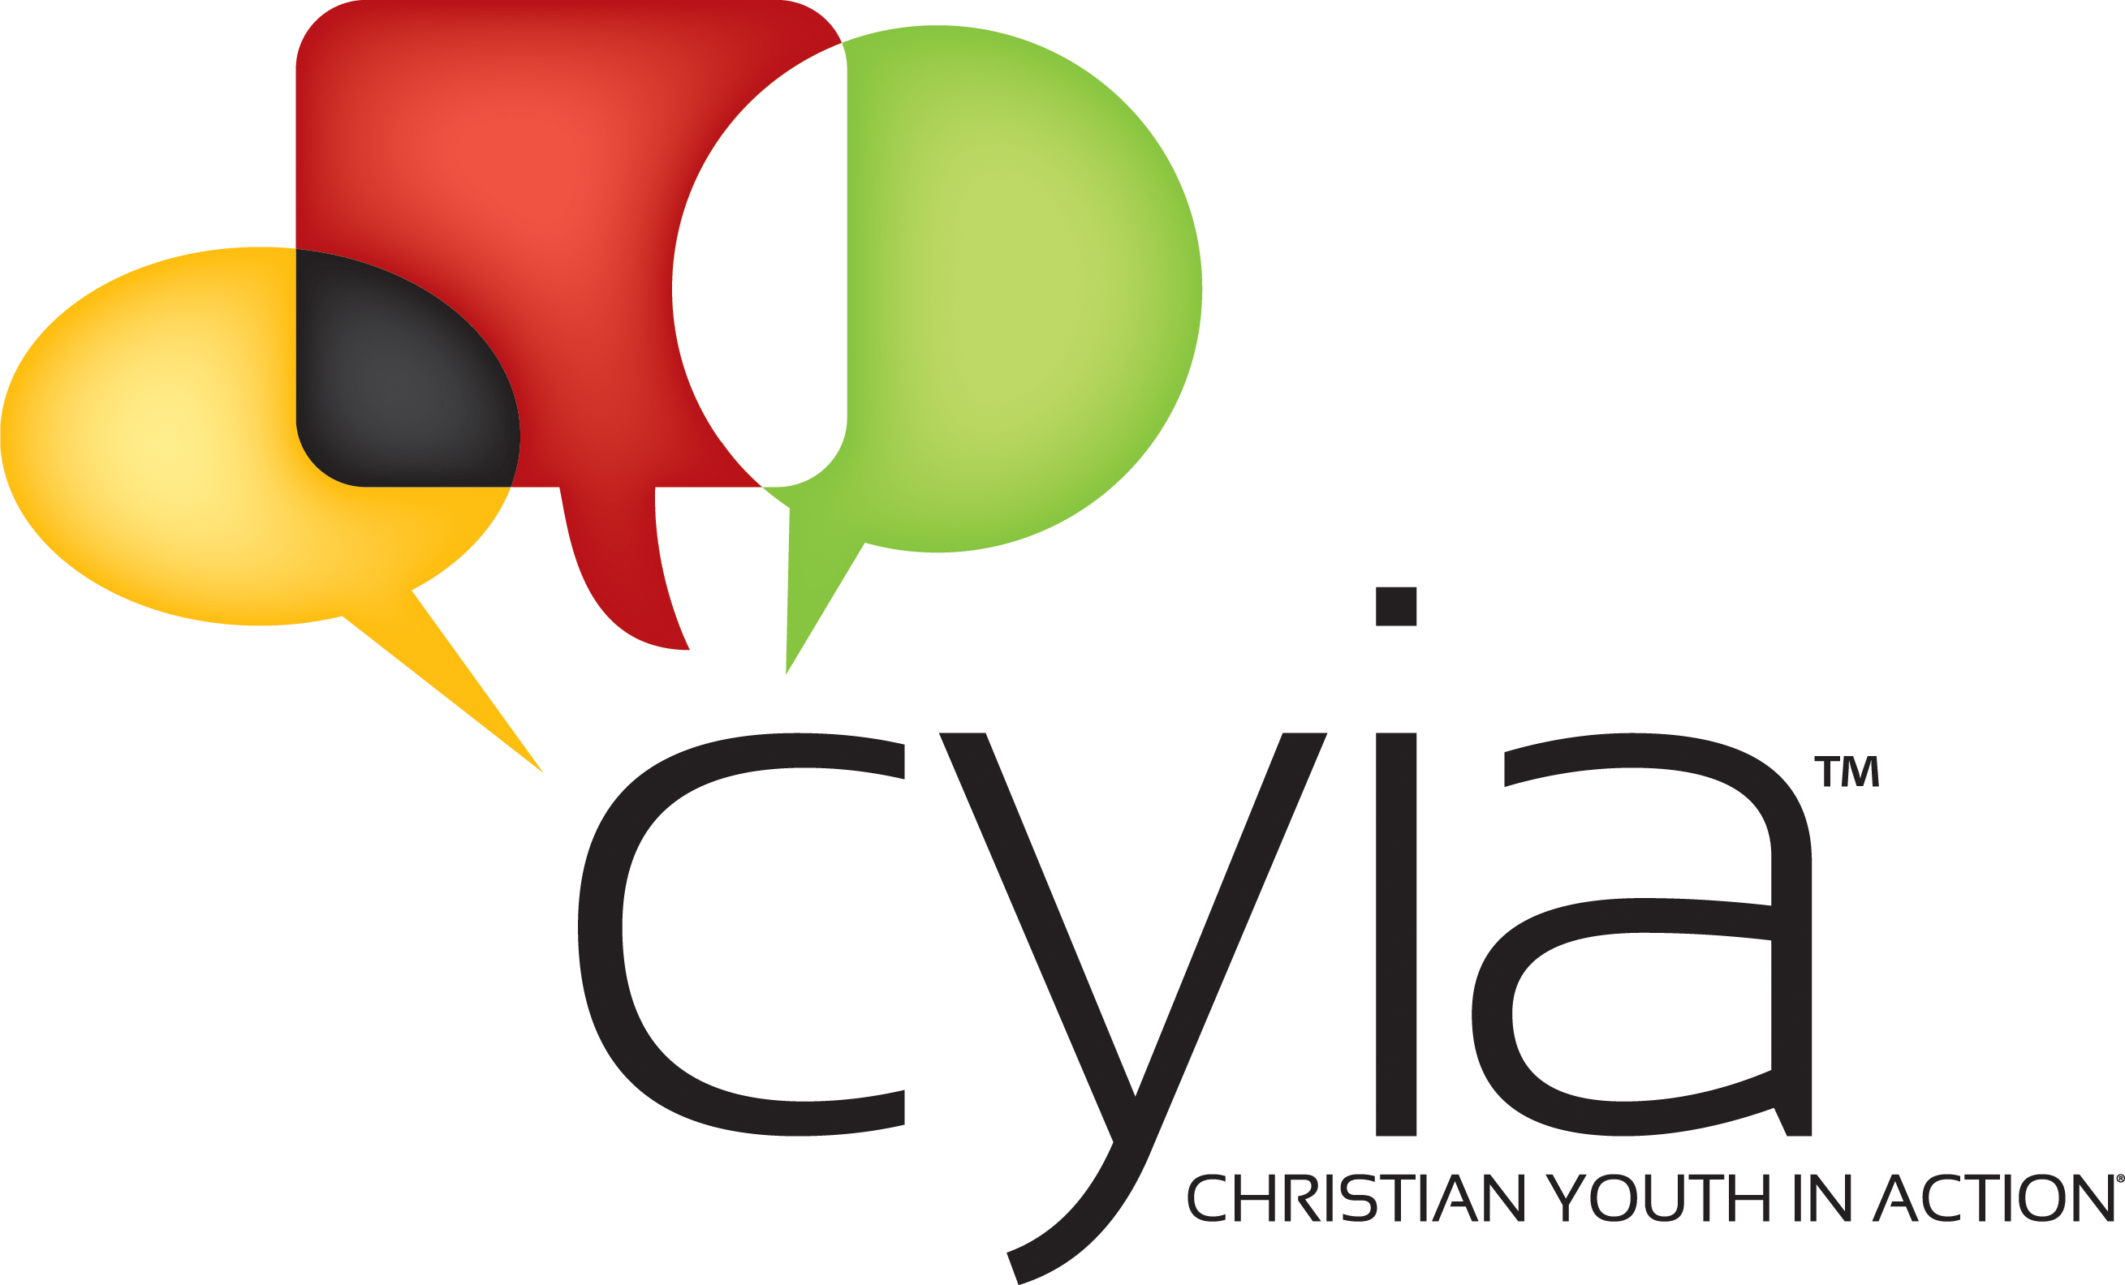

**CYIA 2025**

Training and Summer Missions Opportunities for teens 13 years old and older!

**Saturday, June 14 – Saturday, June 21**

The Springs Ministries

[1950 N M 30, Gladwin, MI 48624](https://www.bing.com/maps?&mepi=109~~TopOfPage~Address_Link&ty=18&q=The%20Springs%20Ministries&ss=ypid.YN431x7826738&ppois=44.023075103759766_-84.35956573486328_The%20Springs%20Ministries_YN431x7826738~&cp=44.023075~-84.359566&v=2&sV=1&FORM=MPSRPL)

**Monday, June 23 – Friday, June 27**

Practice 5-Day Clubs in your local CEF Chapter

Talk with your Local CEF Worker for more information.

CYIA 2025 Application

**Application and application fee of $50** is DUE by MAY 15, 2025

Total Cost: $400*** Cash or check

Check made out to “CEF”

Mail to:

CYIA Registrar, 4301 W. Mt. Hope Hwy, Lansing, MI 48917

Email to [cyiacefmi4301@gmail.com](mailto:cyiacefmi4301@gmail.com)

517-775-1429 (Mr. Hammar’s cell)

Total Cost Via paypal: $415

[cefmi.com/giving](http://www.cefmi.com/giving/) Click on “donations”

Balance is due at CYIA Registration on June 14

***Talk to your local CEF worker to learn ways to help pay for the cost of training.***

This application can be filled out online at: cyiami.com

Keep this page for your use.

**KEEP THIS PAPER TO HELP YOU PREPARE FOR CYIA!**

Once you have filled out this application, mail it to:

CYIA Registrar

CEF of MI, Capital Area Chapter

4301 W. Mt. Hope Hwy

Lansing, MI 48917

Or scan and email it to: [cyiacefmi4301@gmail.com](mailto:cyiacefmi4301@gmail.com)

After you send in your application:

1. Contact those people you listed as references so they can get that form to the CYIA Registrar as soon as possible.
2. Contact your local CEF Worker for the following:
   1. CEF Child Protection Policy

* If you did the Child Protection Policy last year and have not turned 18 yet, you are all set)
* If you have turned 18 since you last did the CPP forms, you must do it again.)
* If you are under 16 years of age, the paper forms for the Confidential Screening Form and Background Check Authorization are adequate)
* If you are 16 – 18 years of age and have never filled out the CEF Child Protection Policy Application, you must do so before attending CYIA.)
  1. CEF Statement of Faith and Workers Compliance Agreement
  2. Set up an interview for CYIA acceptance.

Once your director has told the CYIA Registrar these things are completed, you will receive an acceptance letter.

Preparing for CYIA:

You are strongly encouraged to do the following before arriving on campus for CYIA.

1. Complete the Bible Lesson Study Questions for “Discovering Jesus”
2. Read through “Mary Slessor” Missionary Story and complete the Missionary Story Study Questions.
3. Memorize and recite to your director the verses on the CEF Memory Verse List.

ALL of the documents can be found at cyiami.com or from your local CEF worker.

Thank you for submitting your application for CYIA. We look forward to seeing you in June.

**CYIA Application**

**Deadline for submission is May 15, 2025**

**Notice of Non-Discriminatory Policy**

##### *Child Evangelism Fellowship® admits students of any race, color, ethnic origin, and nationality to all privileges, programs, and activities available through our training programs.*

**PLEASE PRINT LEGIBLY IN INK or type your answers.**

# My local CEF chapter/worker is

**Personal Data**

# Name (as you want it on your commissioning certificate):

First: Middle Initial: Last:

# Gender: M or F

Name you want on your CYIA name tag:

Date of birth: Phone:

Mailing Address:

City, State, Zip:

E-mail:

T-Shirt size (choose one): Adult Sizes

Small Medium Large X-Large XX-large XXX -large

**Parent/Guardian**

Name: Relationship:

(Information needed if different than above)

Mail Address:

City, State, Zip:

Phone: E-mail:

**CEF Ministry and Training Experience: Check all that apply**

1st year CYIA 2nd year CYIA 3rd year CYIA 4+ year CYIA

TCE 1 TCE 2 5-Day Clubs Good News Club Fair Ministry

Other___

**Personal Testimony**

Please provide a written personal testimony in which you tell 1) when and where you received Jesus as your personal Savior and 2) how you know Jesus has saved you. **Returning students may share how the Lord has been working in your life over the past year.**

Please write a brief summary of why you would like to attend Christian Youth In Action and how you plan to use the training you receive.

**Personal References**

You must have 2 people fill out a reference form for you – 1 from a non-relative pastor, youth pastor, or spiritual leader; the second by a non-relative adult friend.

Please write the name and contact information for the two people you are asking to be references for you.

Pastor/Spiritual Leader: Phone:

Email address:

Adult Friend (non-related): Phone:

Email address:

Two forms are included with this application that you can give these two people. The forms can also be filled out online using this link: [Forms - Gravity Forms ‹ CHRISTIAN YOUTH IN ACTION OF MICHIGAN — WordPress (cyiami.com)](https://cyiami.com/wp-admin/admin.php?page=gf_edit_forms&id=6)

**Acknowledgment Statement:**

I understand that completion of CYIA training does not guarantee that I will be accepted for service this summer. I understand that my attitude toward CYIA staff and fellow students does matter.

## I understand that while I am at Grace Christian University for *CYIA,* I am under the authority of the Director of CYIA and all the staff. I understand that I am to follow the rules and guidelines that are outlined in the CYIA Student Guide.

Student Signature:

## **Photograph Release**

I give absolute right and permission to use my photograph(s), likeness or image(s) in a publication, electronic media (e.g. video, Internet, CD), or other forms of promotional materials for *CEF*®. No payment will be made for the use of images taken or submitted by you. I release *CEF*®, their offices, employees, agents, designees, and the photographer from liability for any violation of any personal or proprietary right I may have in connection with such use.

I hereby state I have read carefully and understand the foregoing and know the contents thereof, and I state my agreement with these legally binding agreements as my own free act.

Student Signature  Date

Parent / Guardian Date

**A parent or guardian must also sign with and for a minor (under age 18).**

**Medical History for CYIA Students and Student Staff**

Providing the following information will help the CYIA Leadership Team be more effective in working with your CYIA Student/Student Staff. This information will remain confidential.

Name of Student/Student Staff:

Emergency contact:

Name: Relation: Phone:

Name: Relation: Phone:

1. Date of your last tetanus shot?

2. Mark all that apply:

Anemic  High blood pressure High blood sugar

Low blood sugar Dyslexia Autism Depression  Panic Attacks Seizures If so, how often? Click or tap here to enter text.

3. List any food allergies or intolerances

4. List any drug and non-food allergies

5. Disability or Chronic ailment

6. List all medications you take, both prescription and non-prescription:

**Medical Permission**

I give permission for (student name) to participate in activities with *Child Evangelism Fellowship*®. I will not hold *Child Evangelism Fellowship* and/or its representatives responsible for any injury, illness, or mishap that may occur to the above person.

I authorize the designated *CEF*® representative to sign consent for treatment and release of medical records, whenever required. This person may also sign for medical reimbursements, with my own insurance being primary coverage. (Applies to minors only.)

Birth date of student: (mm-dd-yyyy)  Name of family doctor:

Phone number of family doctor:

Insurance Company: Policy Number:

Name of Insured Person: Relationship of insured to Student:

Phone number for insurance contact:

Signature of Parent or Guardian: Date:

Signature of applicant (if not a minor): Date:

Child Evangelism Fellowship of MI

**Reference Form**

4301 W. Mt. Hope Hwy

Lansing, MI 48917

517-322-2193

This individual has applied to *Child Evangelism Fellowship*® as a summer worker and has chosen you as a reference. A personal recommendation gives insights that would be very helpful in determining the person’s ability to perform his/her responsibilities. Please print and be candid and objective. You may fill out this form online at cyiami.com.

[Forms - Gravity Forms ‹ CHRISTIAN YOUTH IN ACTION OF MICHIGAN — WordPress (cyiami.com)](https://cyiami.com/wp-admin/admin.php?page=gf_edit_forms&id=6)

**Please return this form by May 15, 2025**

Name of Applicant

Name of Reference

1. How long have you known the applicant? _____________________________

2. In what relationship do you know the applicant?

Pastor/Spiritual Leader Non-relative adult friend

3. How well do you know the applicant? (circle one) Very Well Well Casually

4. Is there any reason known to you why the applicant should not work with children?  Yes No

If yes, please comment

5. What is the applicant’s attitude toward authority?

Excellent Good  Average Poor

6. What is the applicant’s general outlook on life?

Positive Pos/Neg  Neg/Pos Negative

7. Does the applicant work well with others? Yes No

If no, please comment

8. Are you aware of any unbiblical sexual tendency in the applicant? Yes No

If yes, please comment

9. What is the applicant’s work ethic? Dependable Undependable

10. How would you rate the applicant’s standards for Christian living?

Good Average Poor

11. How may we contact you if we have questions?

Phone: Email:

Position or occupation:

Address City St Zip

Signature: Date

(Typing your name on the signature line holds same authorization as your written signature)

Mail this reference to: CYIA Registrar, 4301 W Mount Hope Hwy, Lansing MI 48917

Email to: cyiacefmi4301@gmail.com

Child Evangelism Fellowship of MI

4301 W. Mt. Hope Hwy

Lansing, MI 48917

**Reference Form**

517-322-2193

This individual has applied to *Child Evangelism Fellowship*® as a summer worker and has chosen you as a reference. A personal recommendation gives insights that would be very helpful in determining the person’s ability to perform his/her responsibilities. Please print and be candid and objective. You may fill out this form online at cyiami.com.

[Forms - Gravity Forms ‹ CHRISTIAN YOUTH IN ACTION OF MICHIGAN — WordPress (cyiami.com)](https://cyiami.com/wp-admin/admin.php?page=gf_edit_forms&id=6)

**Please return this form by May 15, 2025**

Name of Applicant

Name of Reference

1. How long have you known the applicant? _____________________________

2. In what relationship do you know the applicant?

Pastor/Spiritual Leader Non-relative adult friend

3. How well do you know the applicant? (circle one) Very Well Well Casually

4. Is there any reason known to you why the applicant should not work with children?  Yes No

If yes, please comment

5. What is the applicant’s attitude toward authority?

Excellent Good  Average Poor

6. What is the applicant’s general outlook on life?

Positive Pos/Neg  Neg/Pos Negative

7. Does the applicant work well with others? Yes No

If no, please comment

8. Are you aware of any unbiblical sexual tendency in the applicant? Yes No

If yes, please comment

9. What is the applicant’s work ethic? Dependable Undependable

10. How would you rate the applicant’s standards for Christian living?Good Average Poor

11. How may we contact you if we have questions?

Phone: Email:

Position or occupation:

Address City St Zip

Signature: Date

(Typing your name on the signature line holds same authorization as your written signature)

Mail this reference to: CYIA Registrar, 4301 W Mount Hope Hwy, Lansing MI 48917

Email to: cyiacefmi4301@gmail.com