**Fun and Crazy Days 2025**

**Monday:**

**Lesson: Jesus Loves the Lost-The Lost Sheep**

**There is no fun day because it’s the first day**

**Tuesday:**

**Lesson: Jesus Takes Away Sin-Blind Bartimaeus**

**Fun Day: Wear Colors-Wear as many different bright colors as possible**

**Reason: Bartimaeus was able to see all the bright colors when Jesus restored his sight**

**Wednesday:**

**Lesson: Only Jesus Satisfies-Jesus Feeds the 5,000**

**Fun Day: Food Day- Wear clothes with food on them-such as tee shirts, hats or socks if no clothes then find food stickers to wear**

**Reason: Jesus fed the 5,000 people with only 5 loaves of bread and 2 fish**

**Thursday:**

**Lesson: Jesus Has Power Over Death-Lazarus**

**Fun Day: Crazy Hair Day-Wear your hair in fun and crazy ways**

**Reason: Lazarus hair was probably crazy when he came back to life-the people may have thought it was crazy that he came back to life**

**Friday:**

**Lesson: Put Your Faith in Jesus-The Officials Son**

**Fun Day: Sports Day-Wear your favorite teams sports gear or tee shirt**

**Reason: The Officials Son may have missed out on playing sports and games when he was sick**

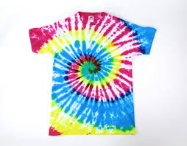 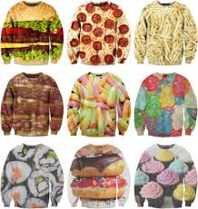 



[This Photo](http://www.dailyclipart.net/clipart/category/sports-clip-art/) by Unknown Author is licensed under [CC BY-ND](https://creativecommons.org/licenses/by-nd/3.0/)