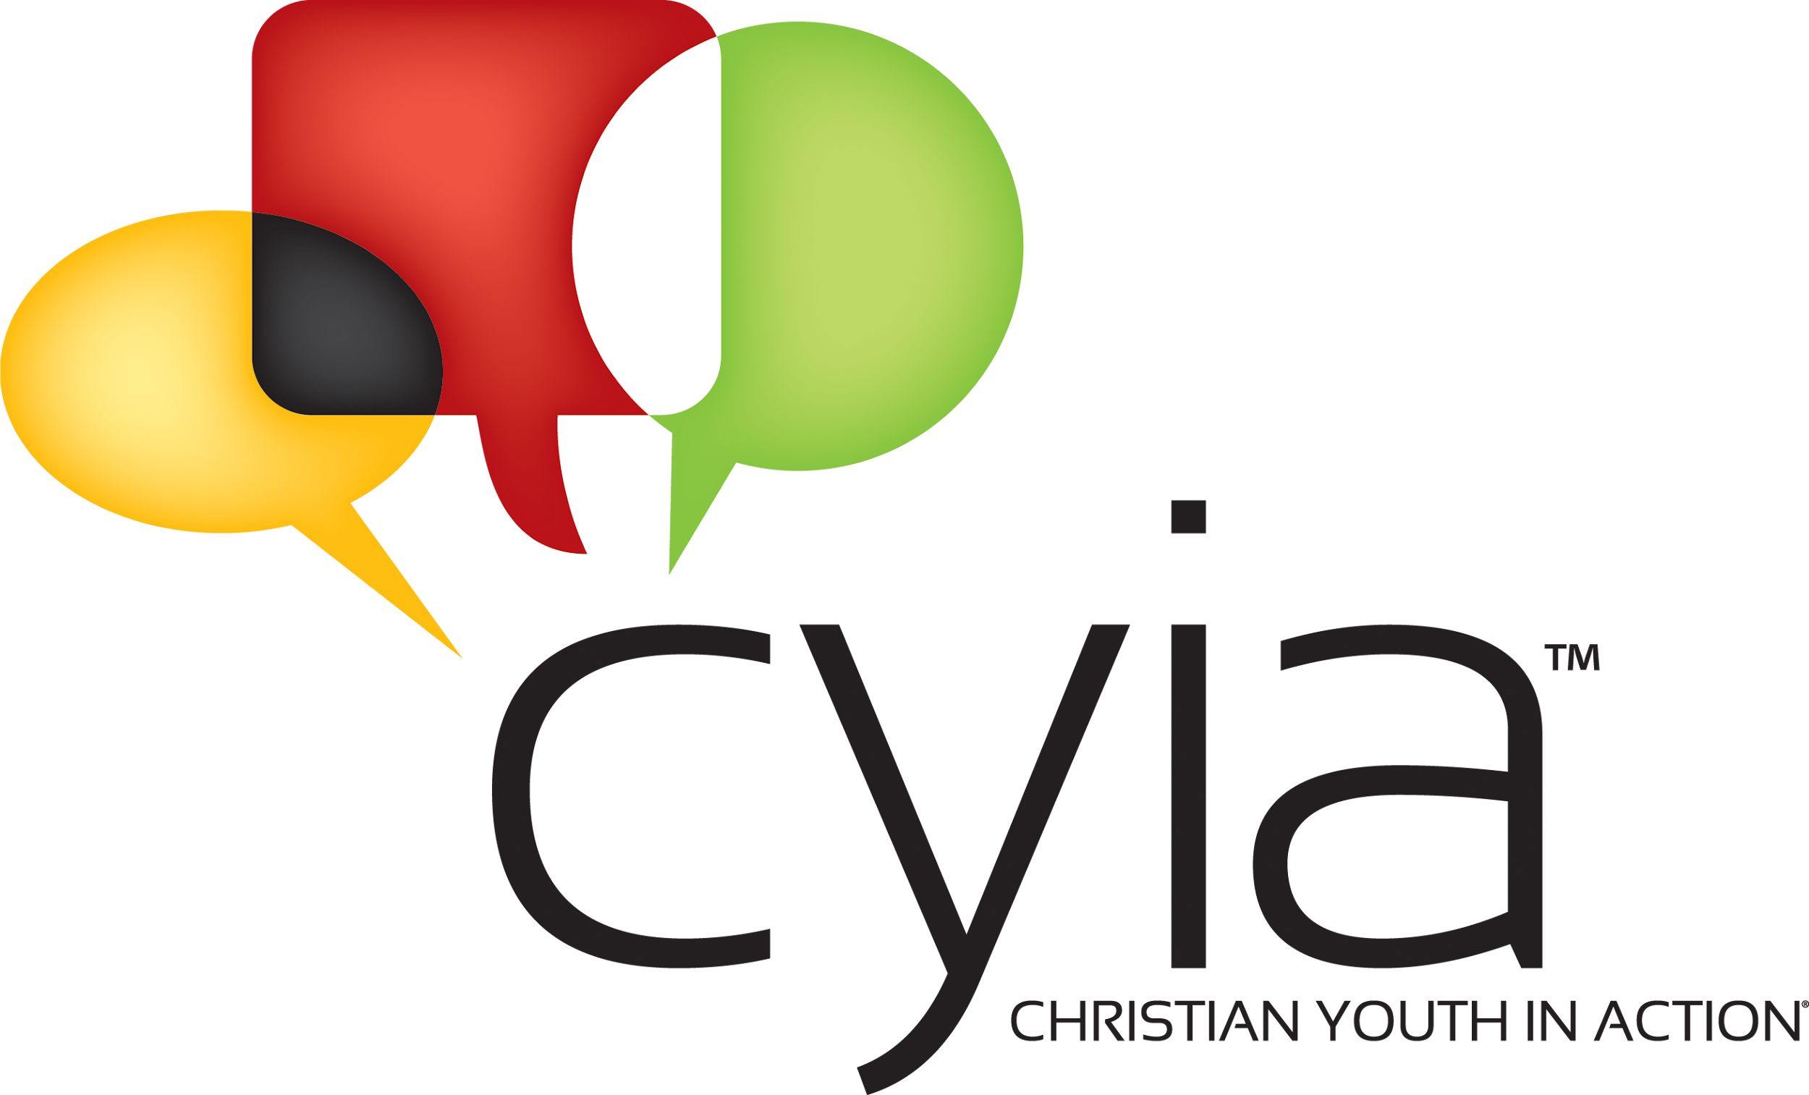
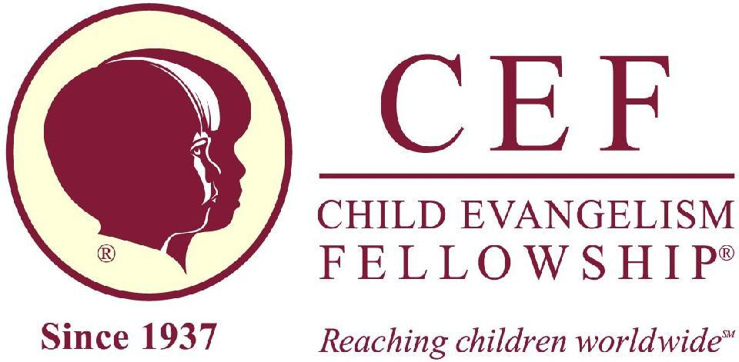

Student Guide
Christian Youth In Action™ 2026
Saturday, June 13 – Saturday, June 20
The Springs Ministries
1950 M-30
Gladwin, MI 48624

The cost of training: $450
$50 of that is due as an Application Fee due when the application is sent in.
The balance of $400 is due at CYIA registration on June 13.

If paying by PayPal: $464

Thank you for your interest in Christian Youth in Action training. We are excited about what God is going to do through you and in you this year at training.

Please read through this Student Guide carefully, paying special attention to the dress code, rules, and what to bring list. If you have any questions, please contact your local CEF worker or Maryann Hammar, CYIA Director at 517-331-5525 or cyiacefmi4301@gmail.com.

Before CYIA:
- Fill out the Application
- Meet with your Local Director for an interview
- Read this CYA Student Guide
- Study and memorize the verses on the CYIA Verse List
- Read through the “Ringu” Missionary Story text
- Do the “Turned Around” Bible Lesson Study Questions

Arrive on Campus
Please plan to arrive at The Springs Ministries between 1:00 – 3:00 PM on June 13.
Leave your luggage in the car until you have gone through the registration line. You will then be directed to take your belongings to your dorm room.

During Registration you will
- Receive your name tag
- Pay any balance due
- Receive your room assignment
- Receive your teaching materials and T-Shirt
- Turn in your prescription medicines to the nurse.
- Turn in your signed Memory Verse list or say your verses to the verse listeners

A copy of the schedule for CYIA and information on sending mail and contacting the CYIA office will be available for your parents.

Overview of daily schedule
Each day begins with your personal quiet time before breakfast, followed by morning classes. In the afternoon, there will be study time and practice with a time of recreation before supper. After supper, there will be more instruction and then group activity time. Each day will end with time around the bonfire and dorm prayer time.

Contact numbers for emergencies: Mrs. Hammar (CYIA Director) 517.331.5525; Mr. Hammar (Administrative Coordinator) 517.775.1429; Mr. Southwell (Assistant CYIA Director) 517.282.6694

The Culture of CYIA:
You are at CYIA for one main purpose: To be equipped to teach boys and girls the gospel. Stay focused on the reason for being at CYIA.

CYIA has a culture of structure. It is important for you to have the right attitude about the structure and program of CYIA. Please ask God to help you stay focused on what He is teaching you and look forward to the children that will hear the message you will be teaching them this summer.

Standards and guidelines expected with CEF
It would be impossible to make rules to govern every type of situation. Good behavior must come from the heart, in love and obedience to Jesus Christ, and should not be mere conformity to man-made regulations.

The following rules, however, are to be strictly observed:
- Respect for staff and fellow students is expected at all times.
- Godly attitudes are to be displayed in every situation.
- Improper speech, vulgarity, profanity, and lying have no place in our fellowship.
- Giving unwanted attention, either verbally, physically, or through social media that could be considered harassment, will not be tolerated and can result in expulsion from the program.
- Students are expected to dress and abide by the dress code.
- Pranks of any kind, played on students or staff, will not be tolerated. Respect for others and their belongings is expected.
- Treat the facilities with care and respect.
- Observe “Lights Out” with the right attitude. Lights Out means no talking, no texting, no listening to music. If you have trouble falling asleep, start praying!
- Anyone under 18 years of age will not be allowed to drive off campus during the time of CYIA. You must have permission to leave campus and must always be with a staff person.
- Be on time for meals, classes, study groups, and group activities.

CYIA Dress Code
As followers of Jesus Christ, we want to dress in a modest, neat way. There are many different ideas of what “modest” is, so this is the standard we would like to adhere to.


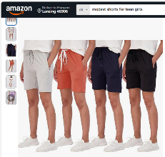
Ladies: Slacks, jeans, skirts, dresses, capris, and shorts are all appropriate attire for the camp setting. Skirts and dresses should be no shorter than just above the knee. The length for ladies’ shorts need to be at least halfway between the hip and the knee or longer. The pictures show examples
from Walmart and Amazon.com. Shirts should not be low cut or show any skin between the shirt hem and the top of the bottoms you are wearing when your hands are raised. No tank tops please.


Ladies’ swimwear: Modest one piece swimsuit. No tankini’s please. You may be asked to wear a pair of shorts and or a T-shirt over the suit while swimming. Please plan to wear a cover-up or shorts and shirt to and from the waterfront.

You will want to bring nicer clothes for the Commissioning Service on the last day. You will also want to bring clothes for paintball.

Men (students)



Gentlemen: Jeans, slacks, and shorts are appropriate. Shorts should be no shorter than halfway between the hip and knee. T-shirts, button-up shirts are acceptable. Please, no tank tops.

Swimwear: Swimming shorts that are a modest length are requested. Please wear a shirt to and from the waterfront.

You will want to bring nicer clothes for the Commissioning Service on the last day. You will also want to bring clothes for paintball.

If at any time you are asked to change, please do so with a right-hearted attitude.
Camp Rules:
No Gum in any part of the facilities.
Everyone is required to take a deep water test to swim in the deep end.

Cell/Device Policy
Students will be allowed to have their devices with them during the day. The CYIA staff will trust you to adhere to the following guidelines:
- Devices can be used in class to view notes and take notes. If you are not using devices for class notes, they must be turned off and put away, except during free time.
- No devices at the meal table.
- You can use your device for your Bible in class and chapel.
- No internet access, only data on your phone will be available. Use of your device for inappropriate texts or viewing will result in your device being taken away.
- Failure to follow these rules will result in your phone/device being taken away and not returned to you until the last day of CYIA. Failure to comply could also lead to you being sent home from CYIA training.

What to bring to CYIA
- Dorm supplies: Bedding, bath linens, toiletries, fan, alarm.
- Clothes that adhere to the dress code; something nice for Church on Sunday and commissioning service.
- Bible (KJV or ESV for teaching times) and your preferred Bible for quiet time
- Pencils, pens and paper
- Light jacket or sweatshirt and rain gear
- Memory verse list
- Musical instrument and sheet music or accompaniment tracks (if desired) to do a special number at the evening chapels.
- Required medication (You will need to talk with a staff member at campus registration.)
- Phones and tablets are allowed and can be used within the guidelines given above.
- There will be up to 12 people in one room with three toilets, sinks, and showers. There are no dressers in the dorm rooms and no place to hang clothes. If you have clothes that need to be hung up you may have to hang them on the bunk or we will see another way to hang your clothes.
- There will be no washing machines available unless there is an emergency.
- There is no gum allowed at the camp so do not bring them.
- Extra money is needed for paintball and canteen.

Please do not bring anything from home that will take your focus away from why you are at CYIA.

Mail and email:
CYIA, (student’s name), The Springs Ministries, 1950 M-30, Gladwin, MI 48624.

They can also send a letter via email to cyiacefmi4301@gmail.com with the student’s name in the subject line. These emails will be opened and printed for the student by Mr. Hammar, Administration Coordinator, or Mrs. Hammar, CYIA Director.

Commissioning Service The Commissioning Service is the culmination of the training and the beginning of your ministry. Saturday, June 20, 2024 3:00 PM At The Springs Ministries
**Evening meal will not be provided

